Configure Cloud Watch & SNS
Please configure VPC / use default vpc as per your requirement.
Click “EC2” service.
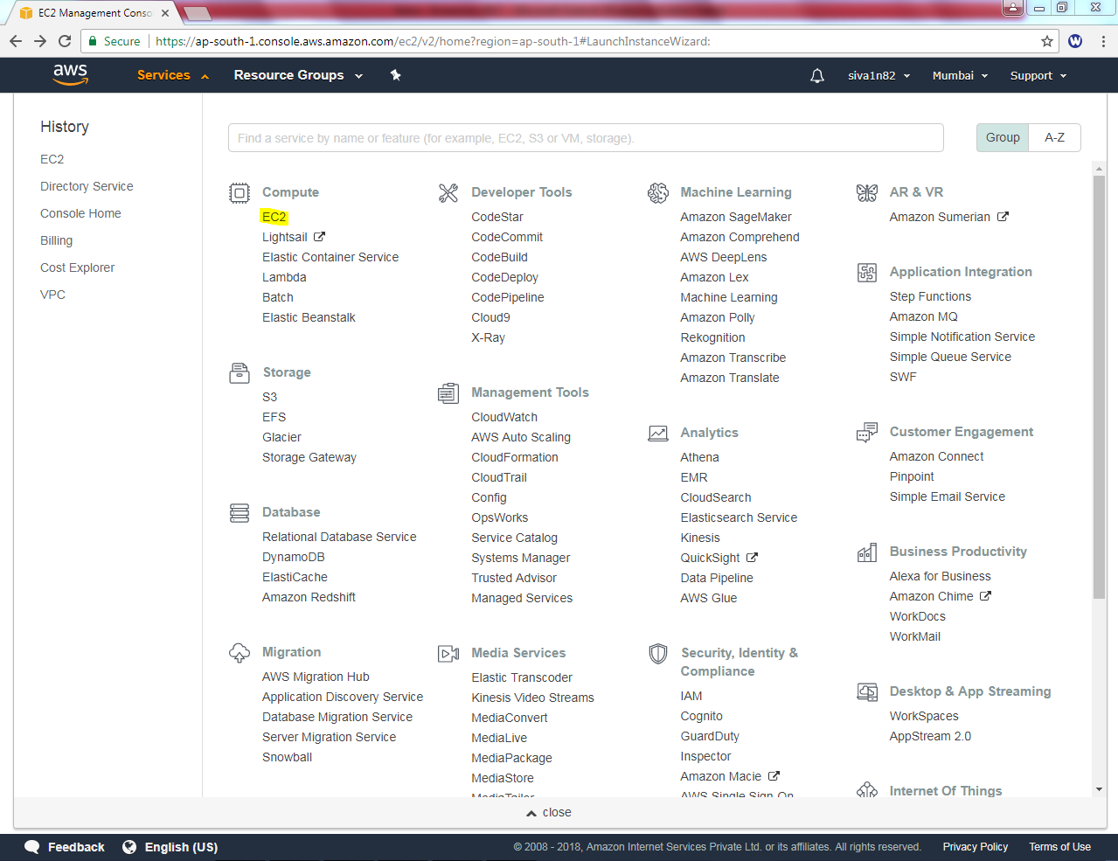

Launch isntnace Select “Linux”.
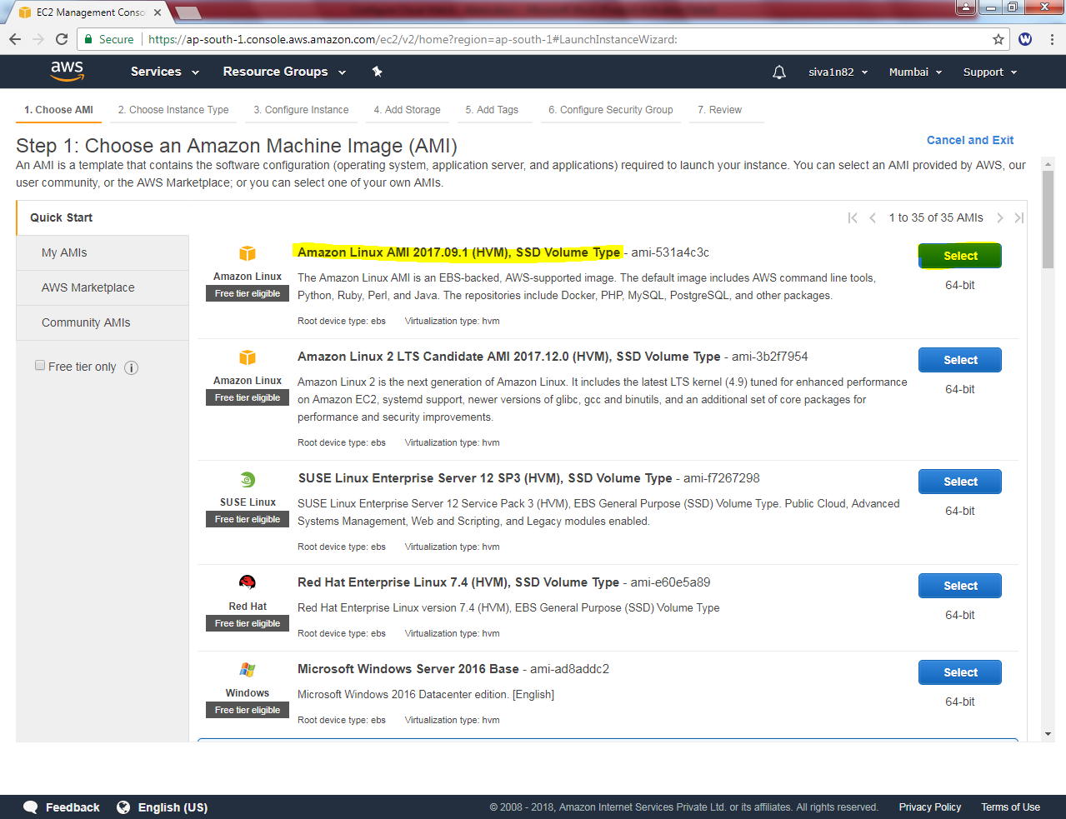

Select “General purpose – t2.micro”
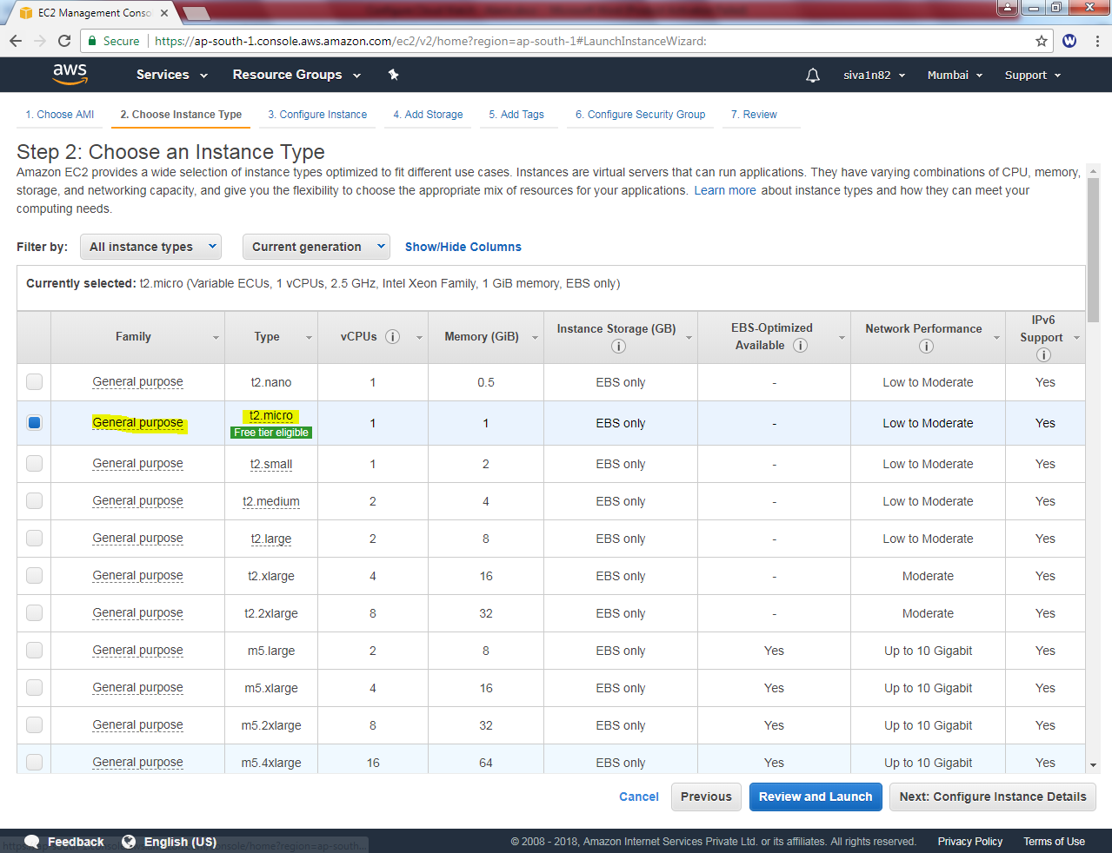

Select Network “Sansbound_VPC_Chennai”
Subnet: “Sansbound Mumbai Pubic Subnet”
Auto-assign Public IP: Enable

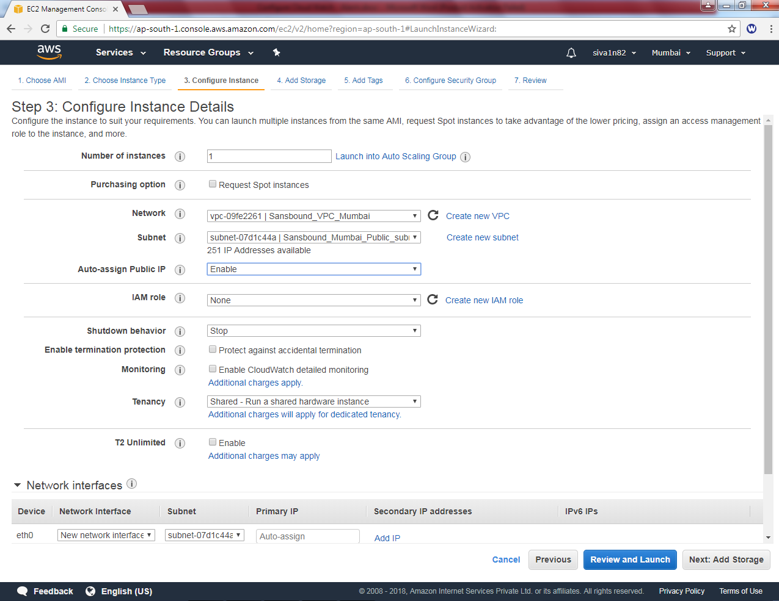

Leave default and click “Next”.

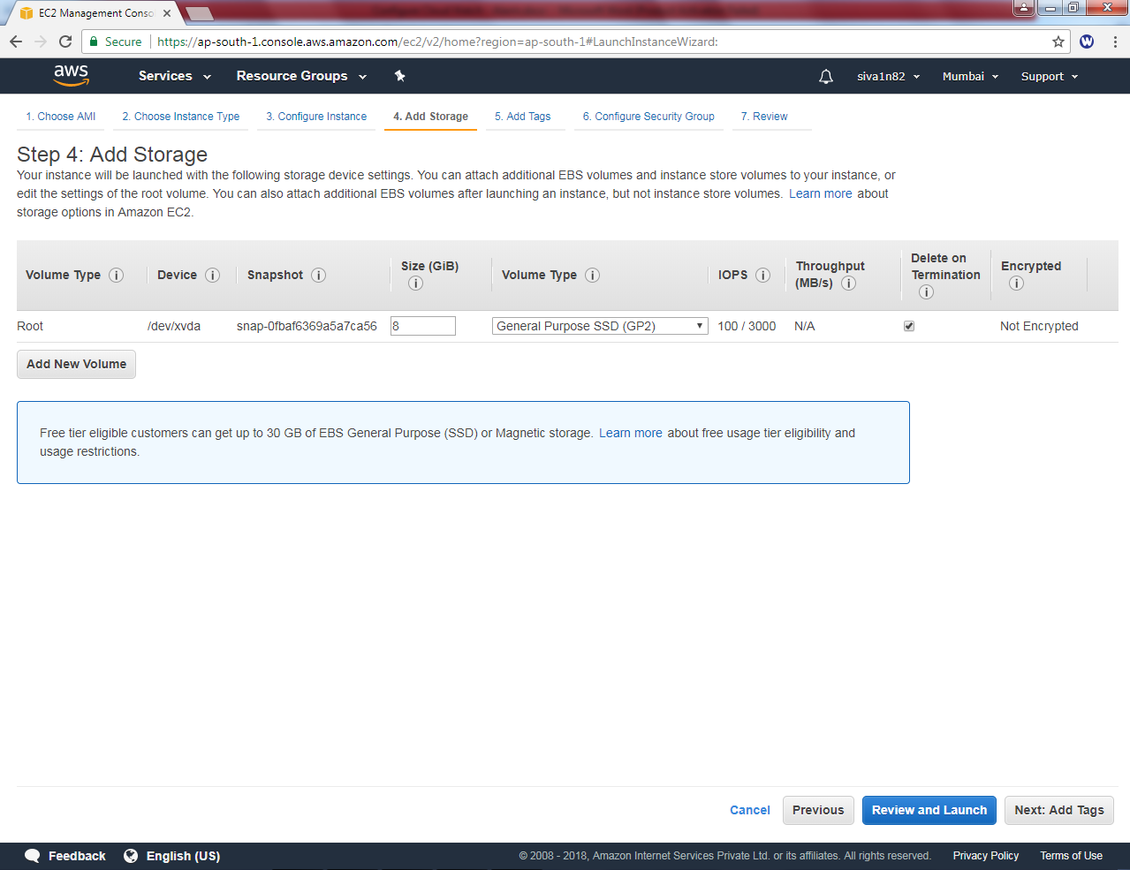

Type name as Linux Server.

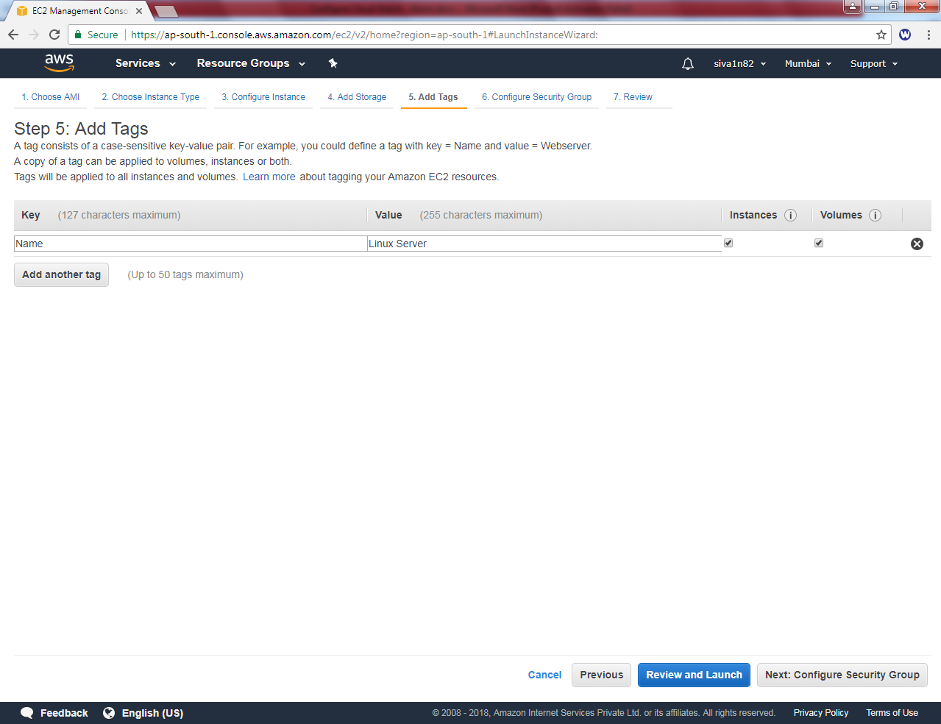

Create a new security group as Linux-Sec-Group

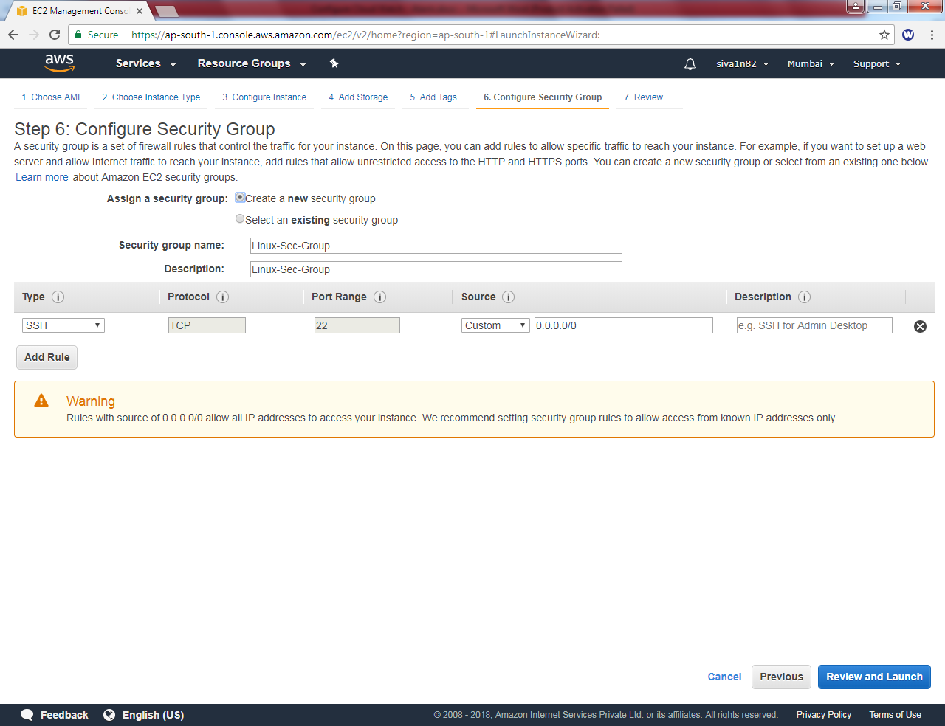

Leave default and click “Next”.
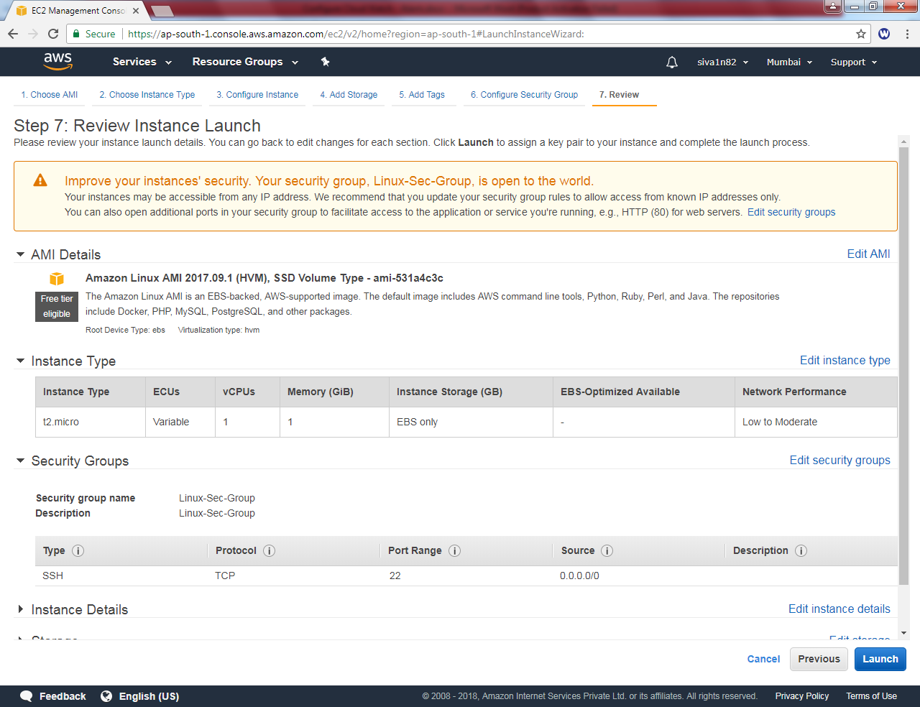

Click “Launch”.

Click”Choose existing key pair”.

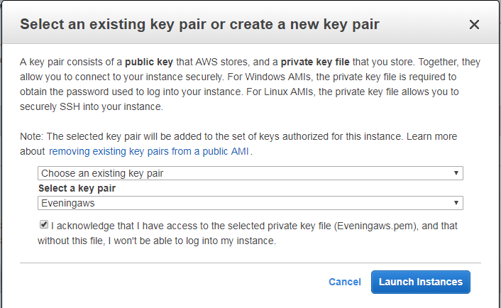
Click “I acknowledge”.
Then click ”Launch instance”

Click “View instances”
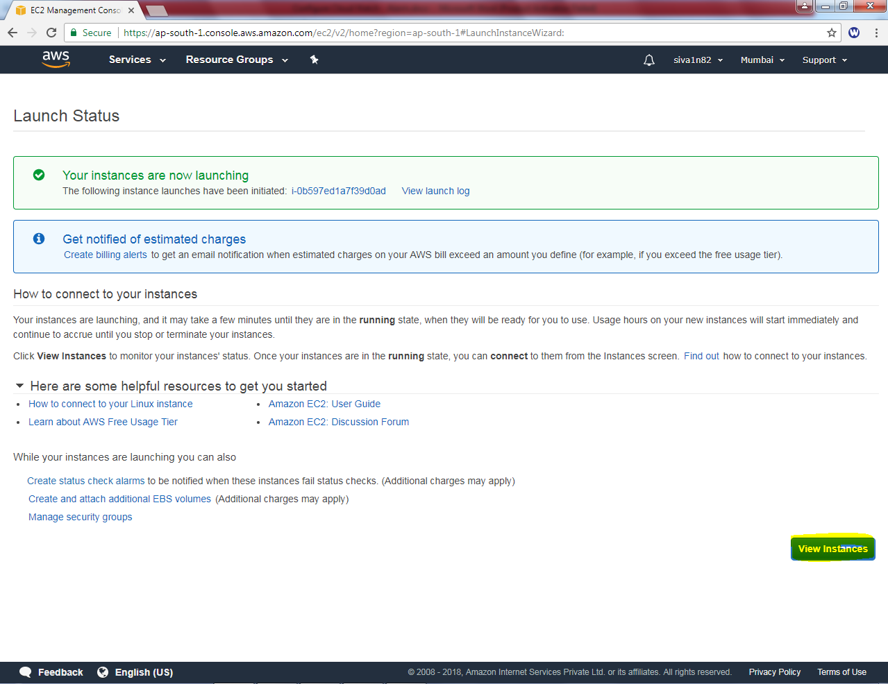

Go to EC2 instances
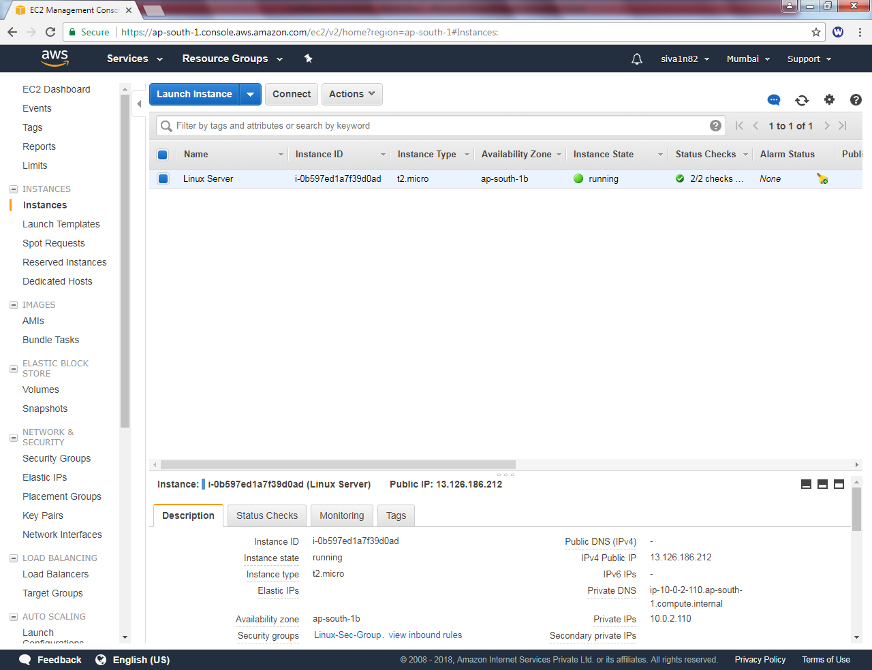

Click “Enable detailed monitoring”.
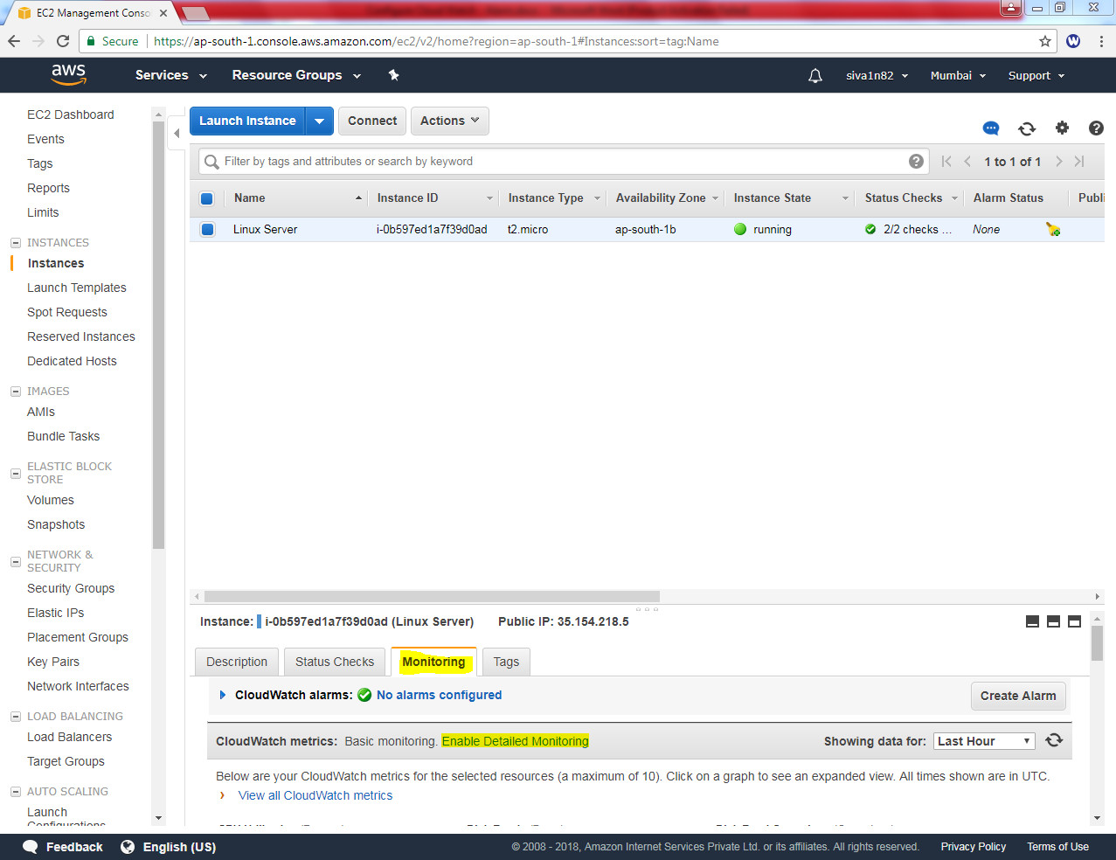

Click “Yes, enable”.
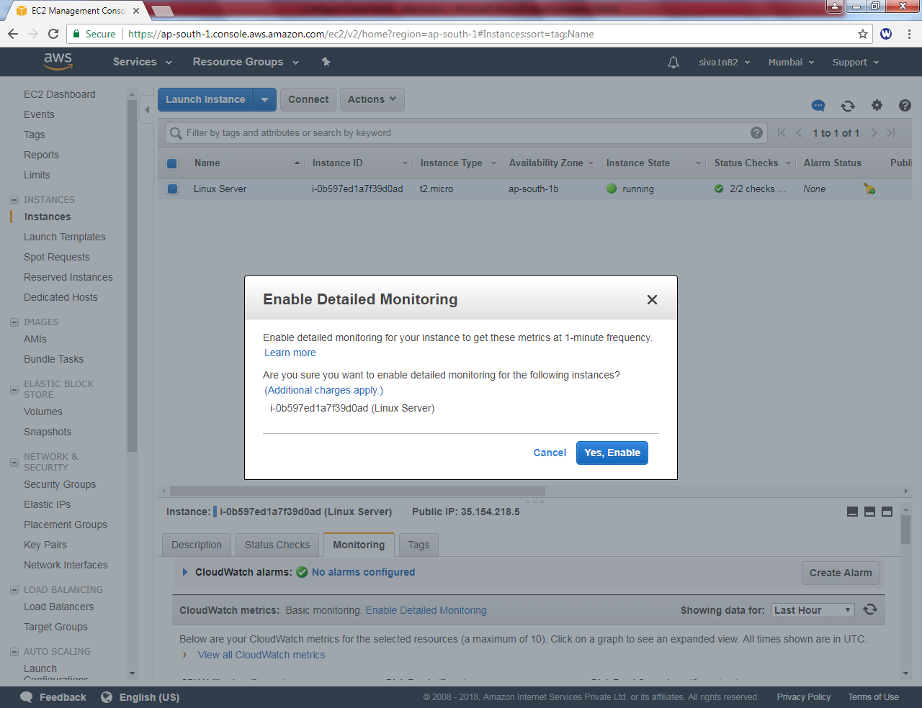

Click “Close”.

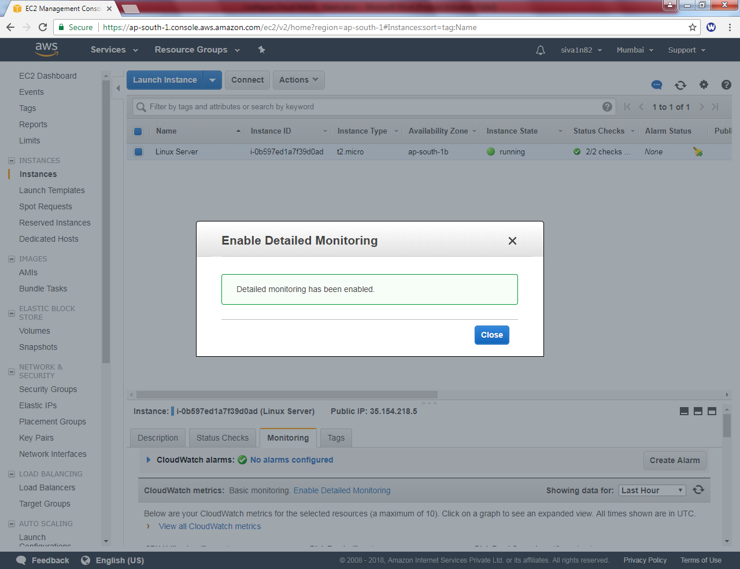

Type “SNS”.

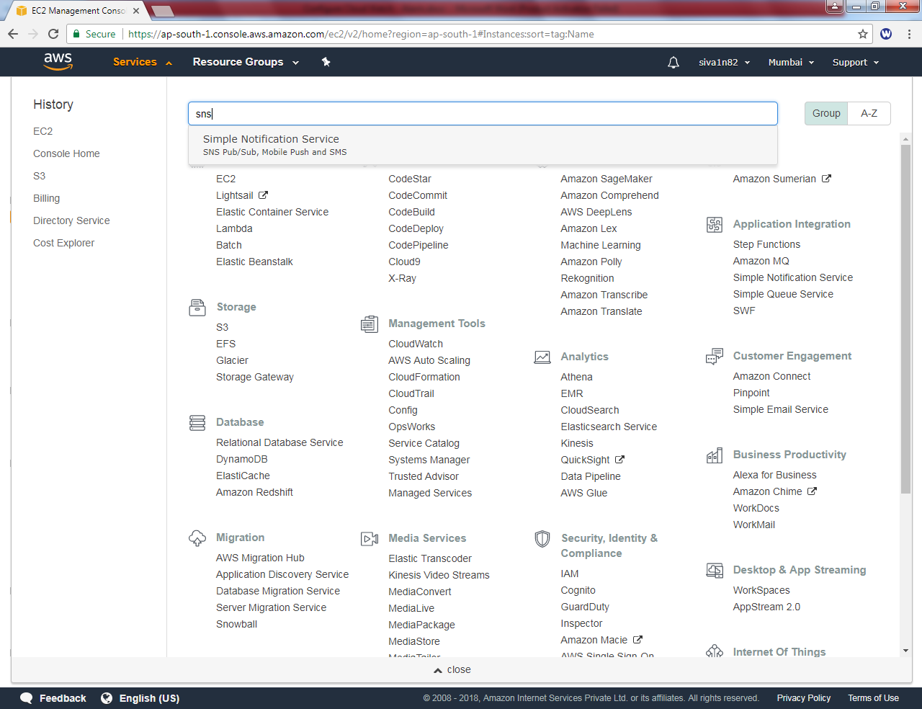

Click “Get started”.

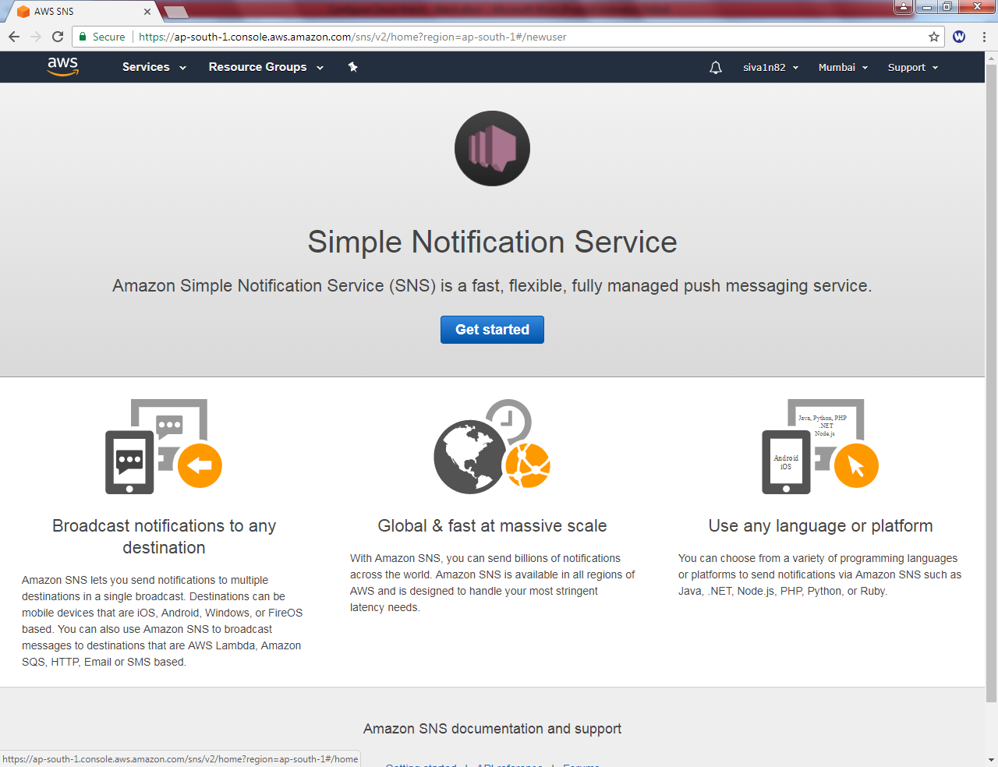

Click “Create topic”.

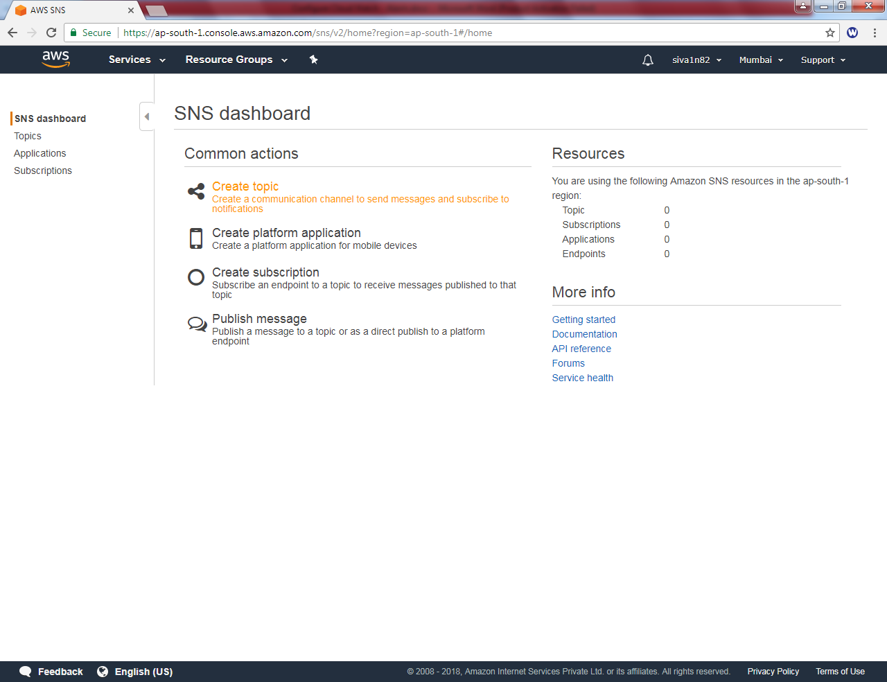

Type “ Topic Name” Linux_SNS
Type “Display Name” Linux_SNS

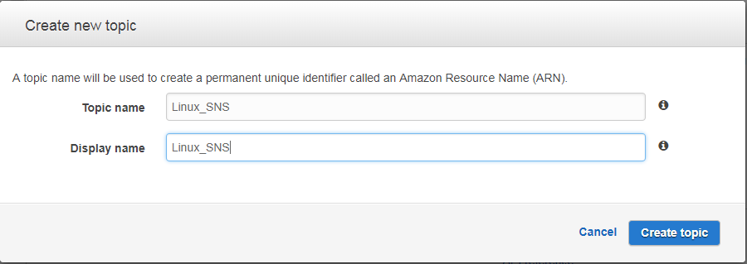

Click “Create topic”.

Click “ Create subscription”.
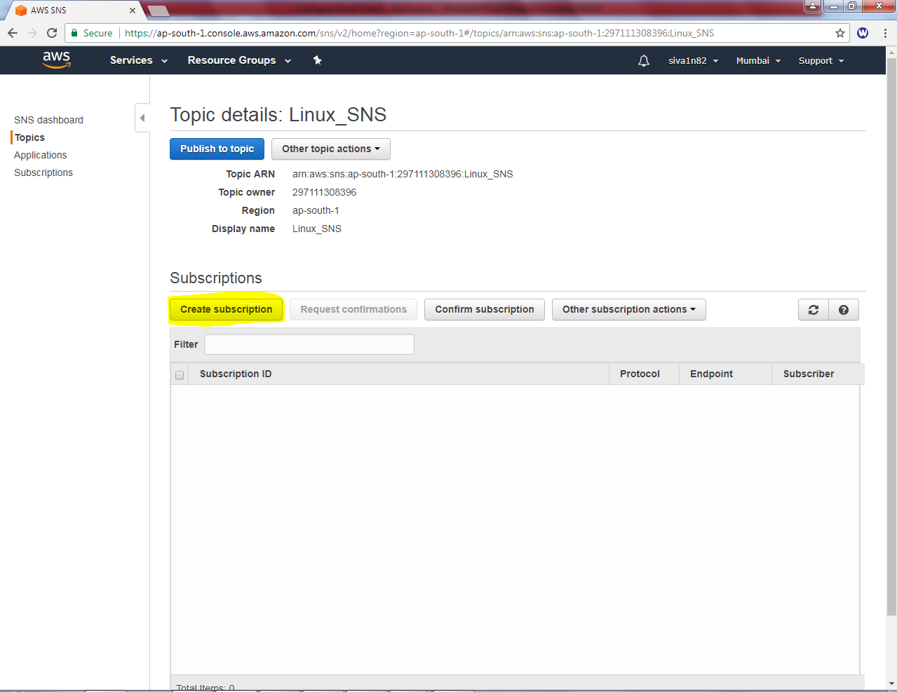

In Protocol, select “Email”.
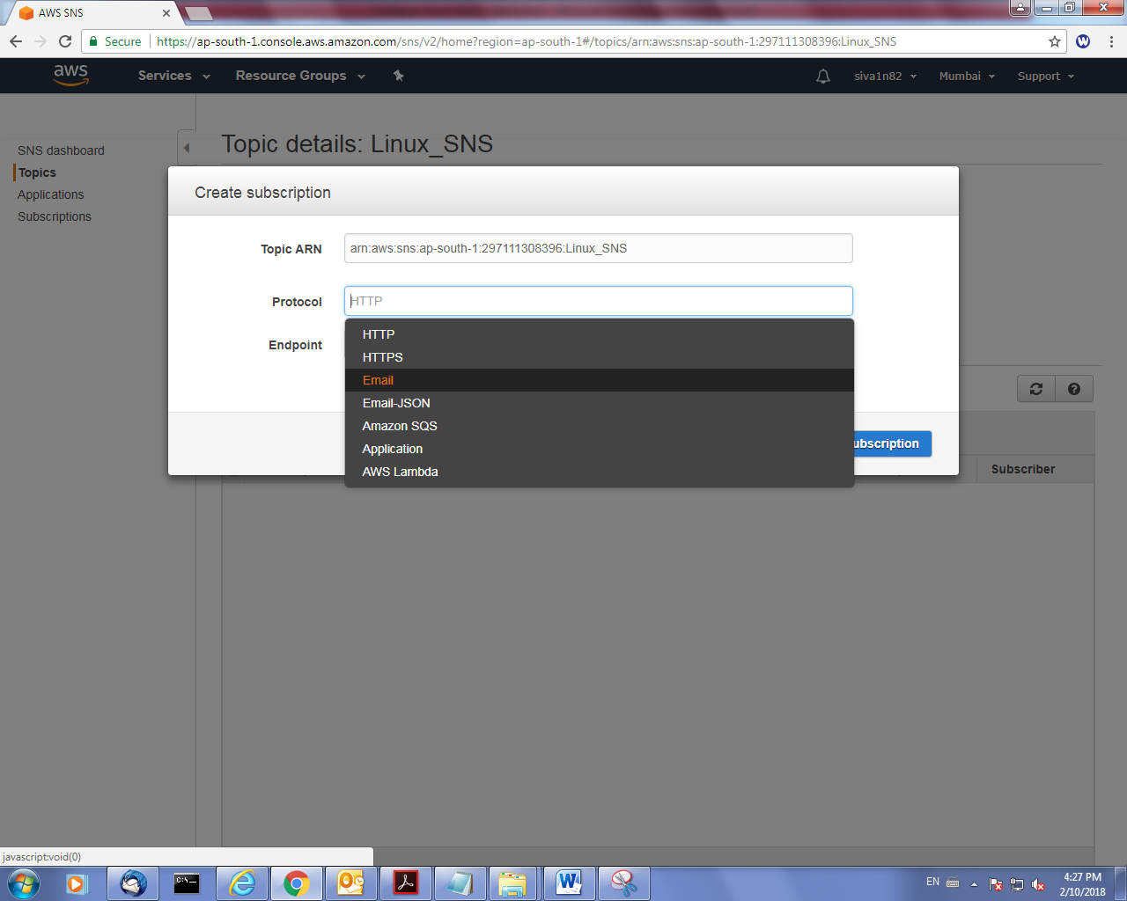

Type your name email id in endpoint.

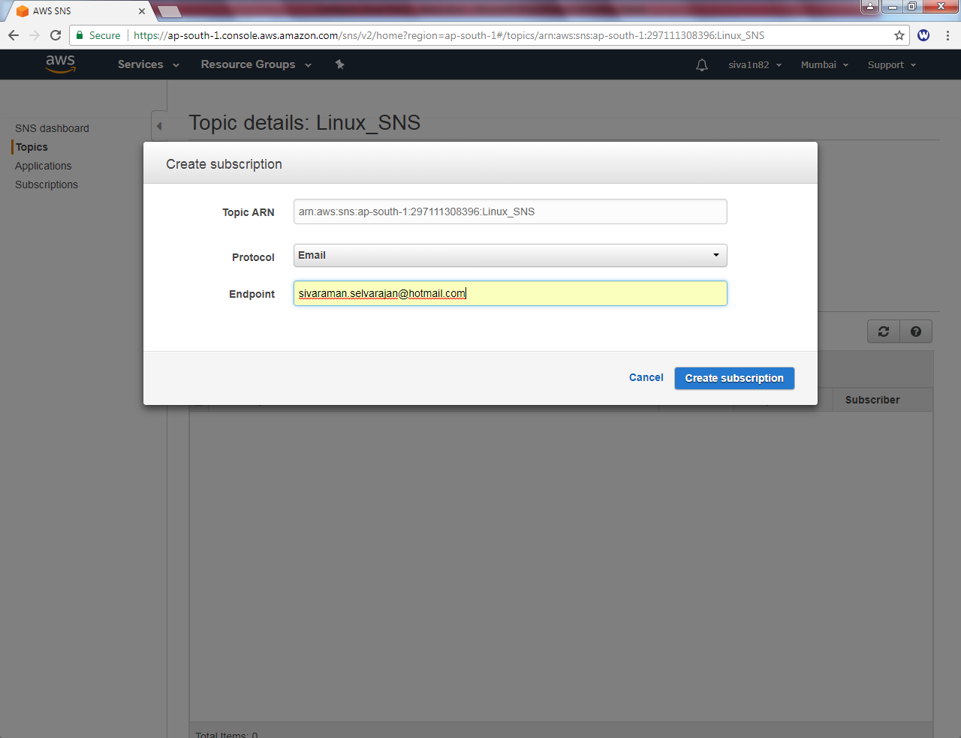

Click “Create subscription”.

Now it’s in pending confirmation, we need to confirm. Go to your email id entered in endpoint.
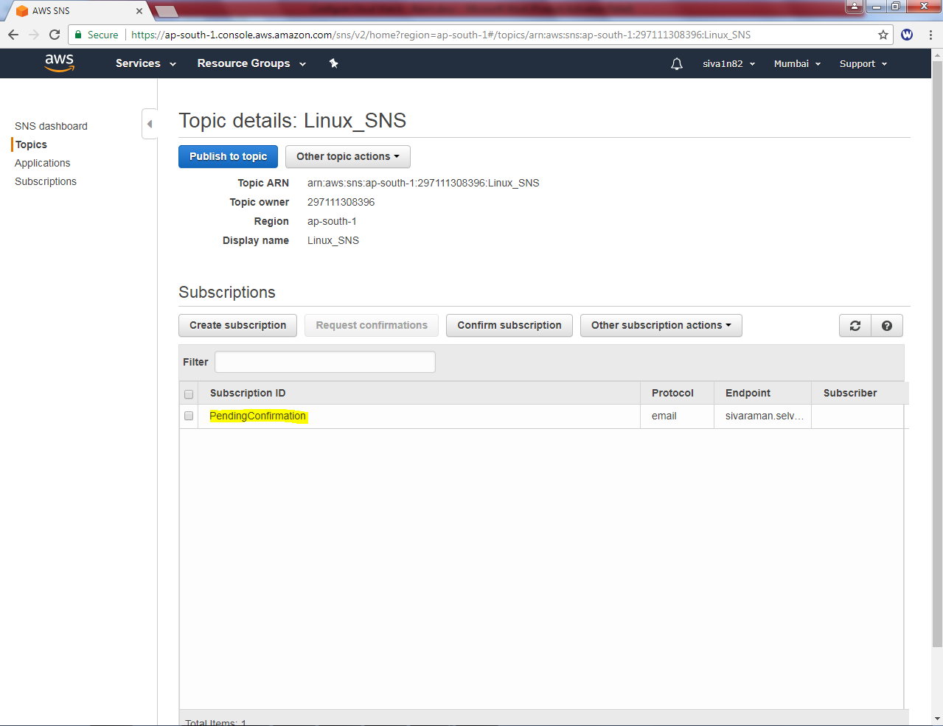

Login to email id and Click “Confirm subscription”.

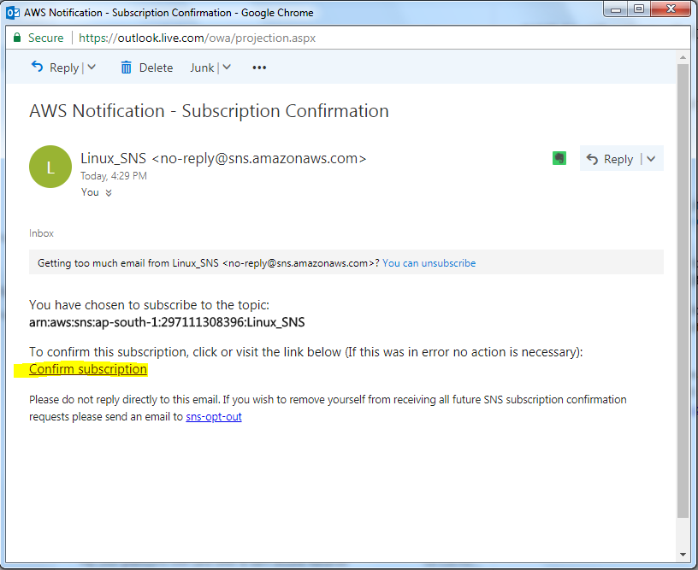

Your subscription has been confirmed.

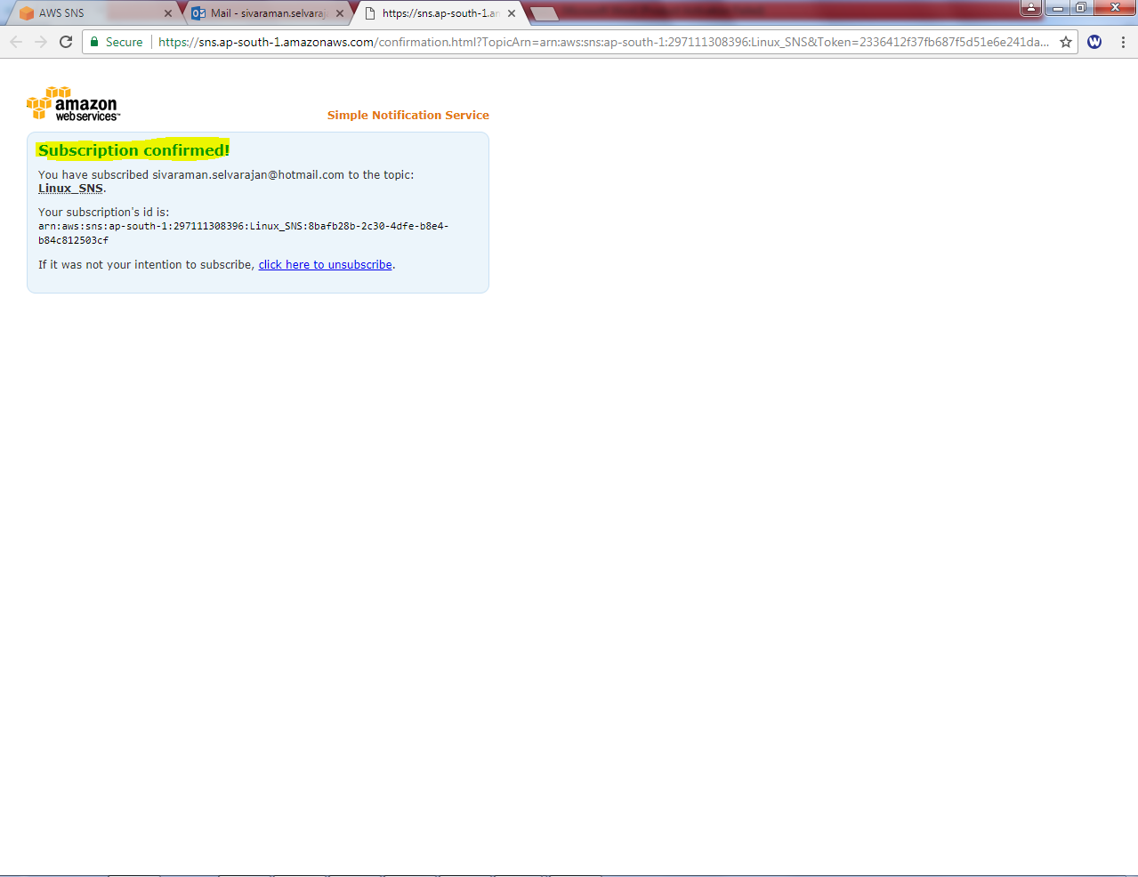

Click “refresh”.

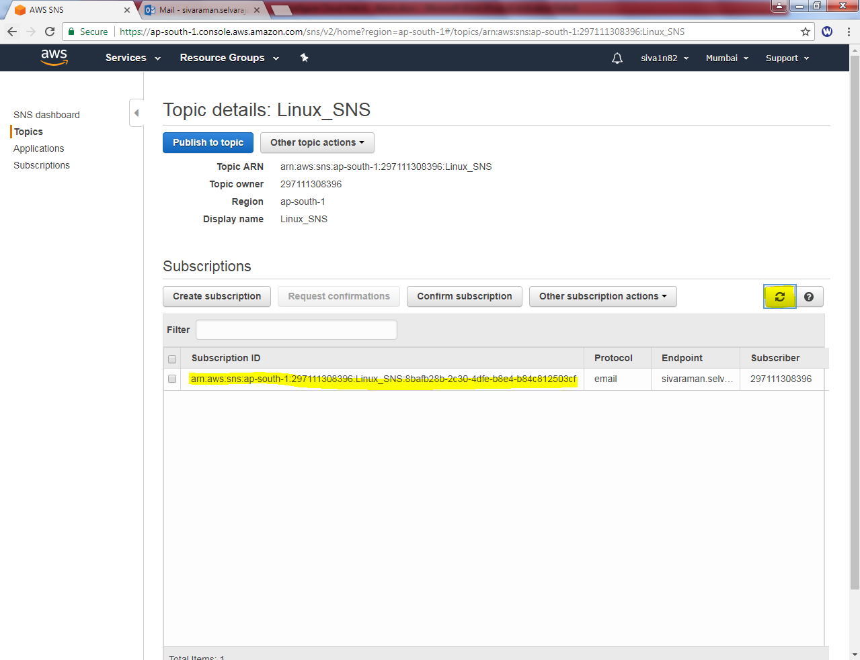

Go to EC2 instance (Linux)

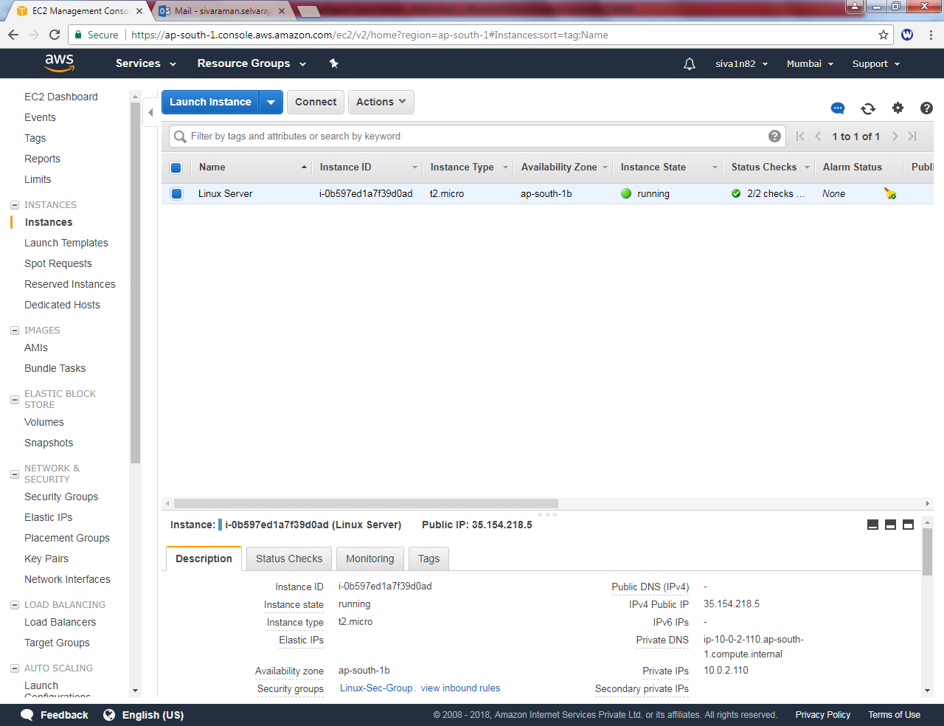

In Monitoring tab, Click “Create Alarm”.
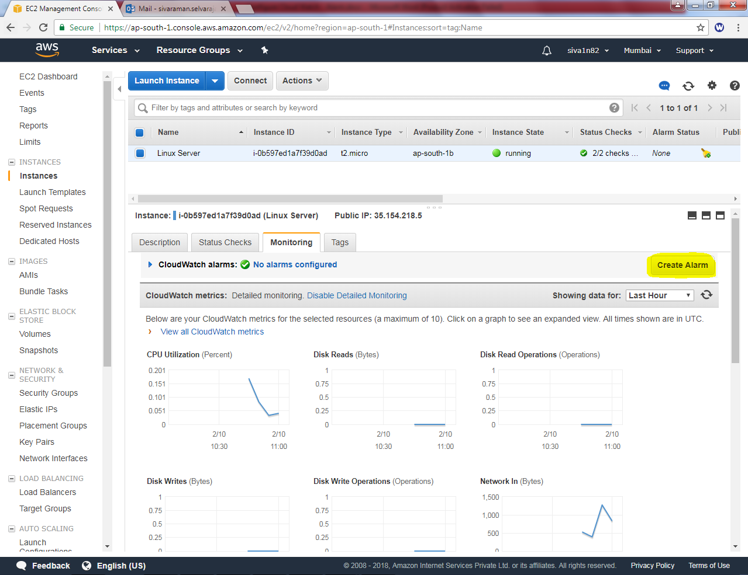

Click “Create Alarm”
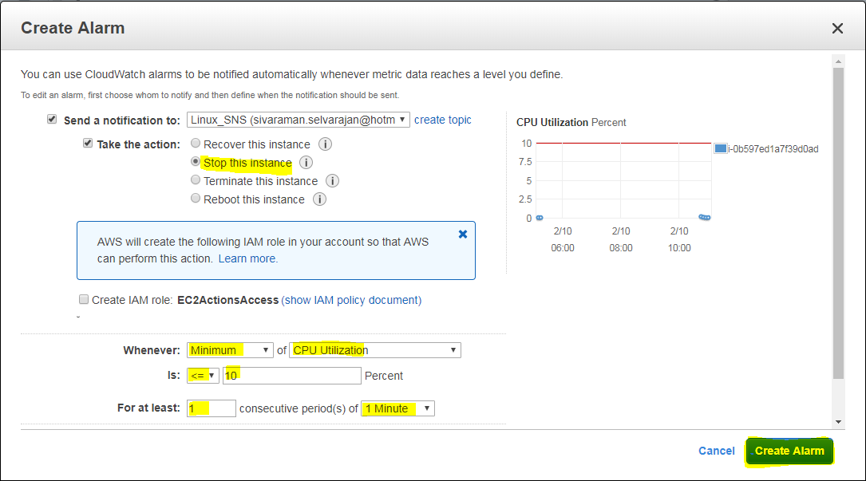

Please see the requirements as below.
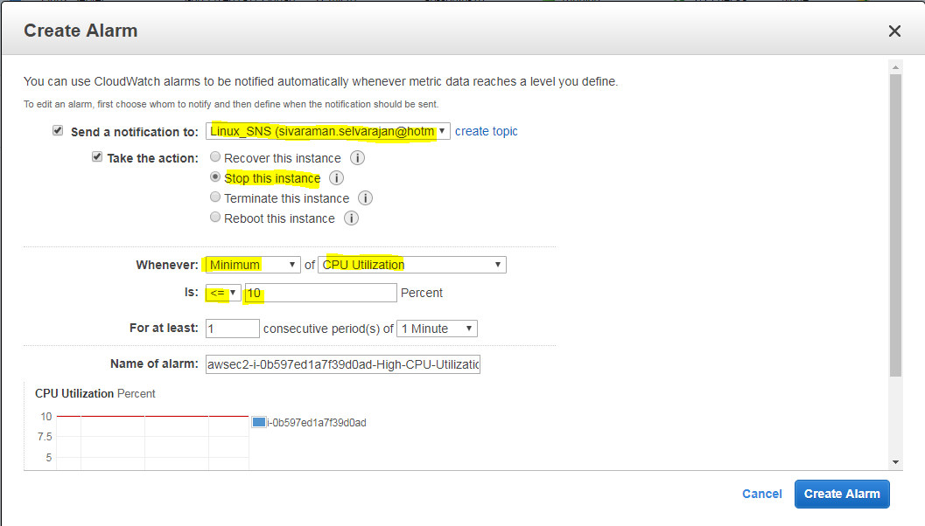

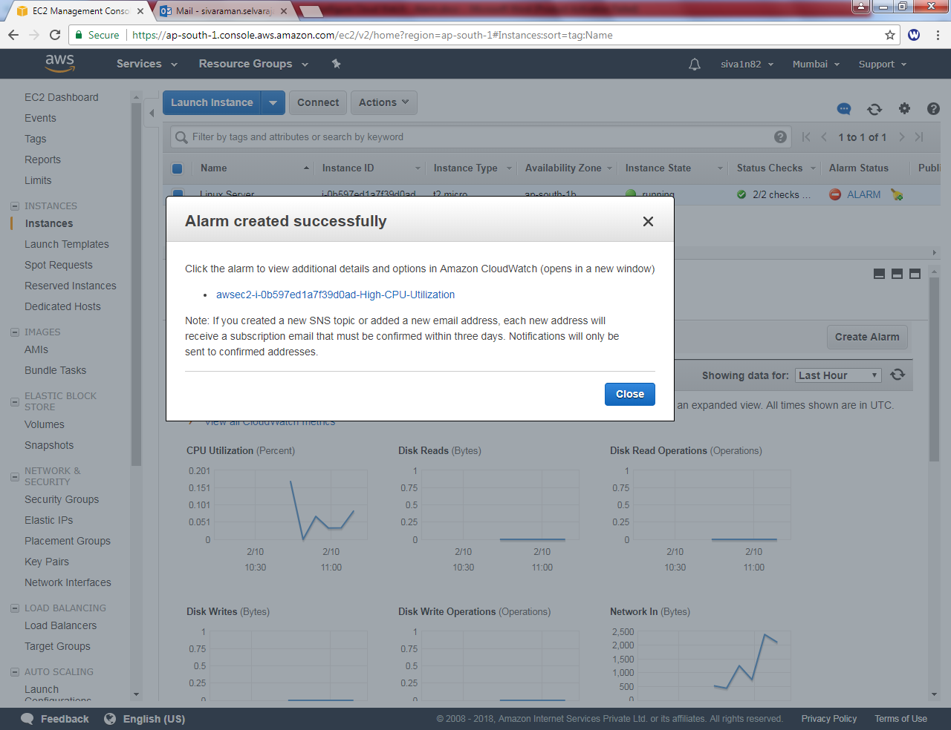

Click “Refresh”.
You can able to see that instance is getting stop.
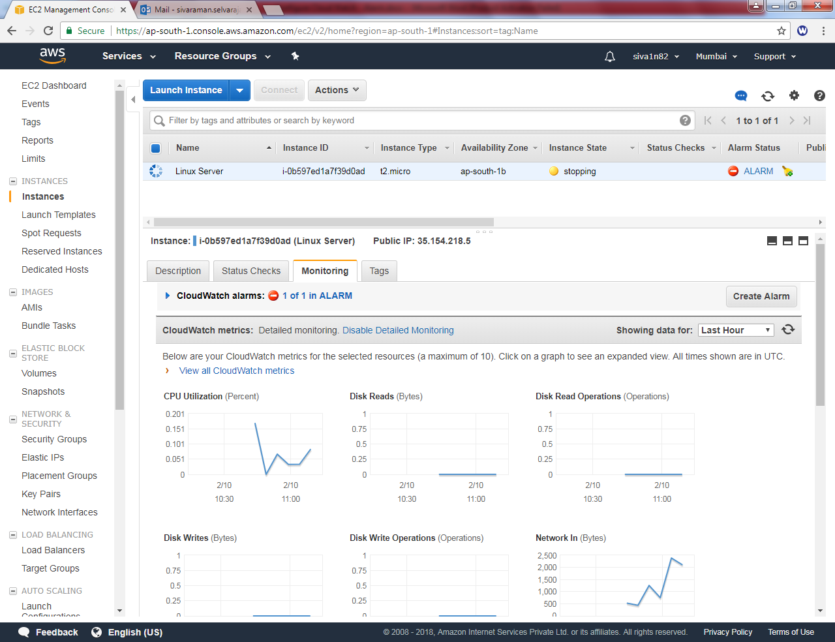

Now the instance is stopped.

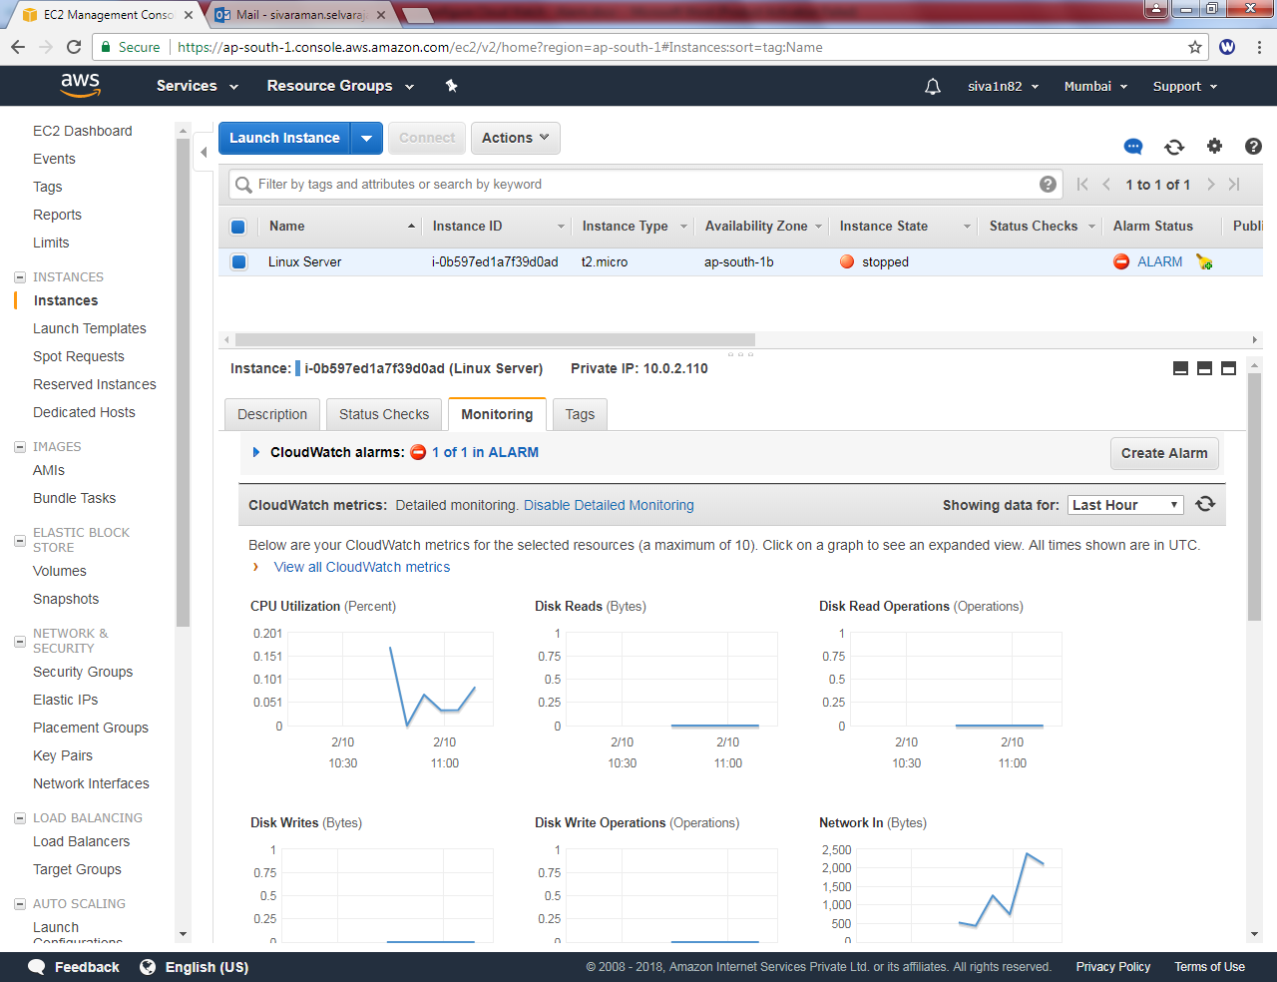

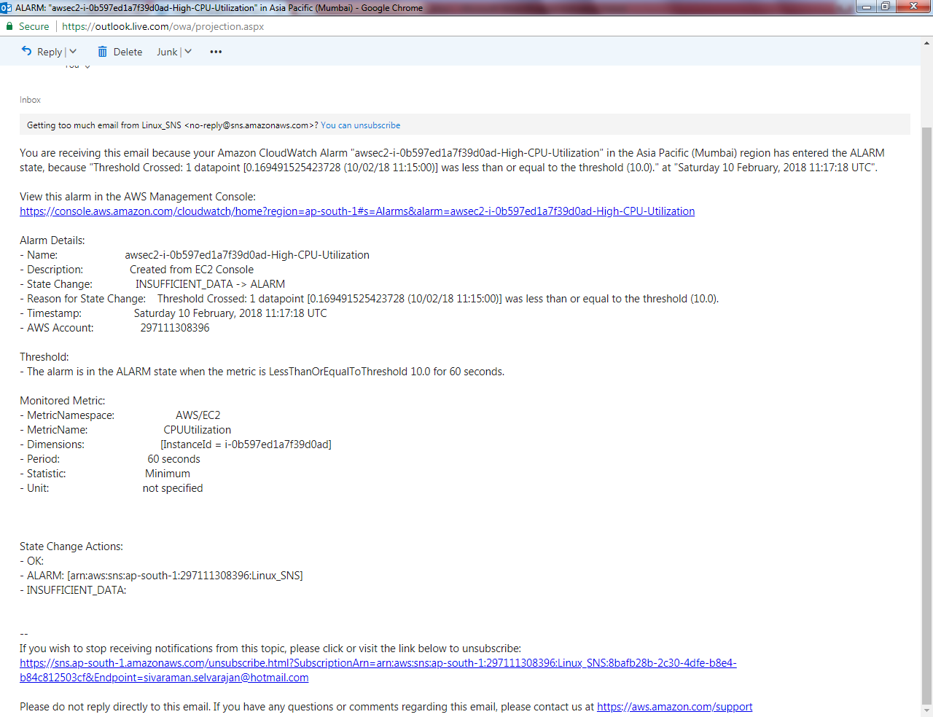

You have successfully configured and tested Cloudwatch.

We need to delete the alarm.
Type SNS in aws console.
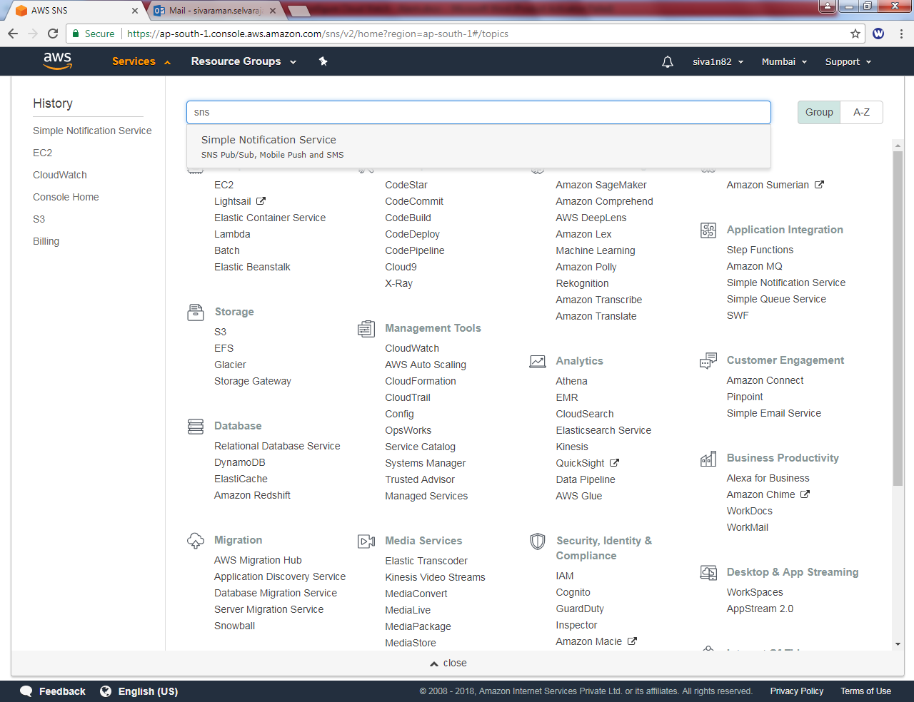
Click “Simple notification service”.

Click Topics and then “Linux_SNS”
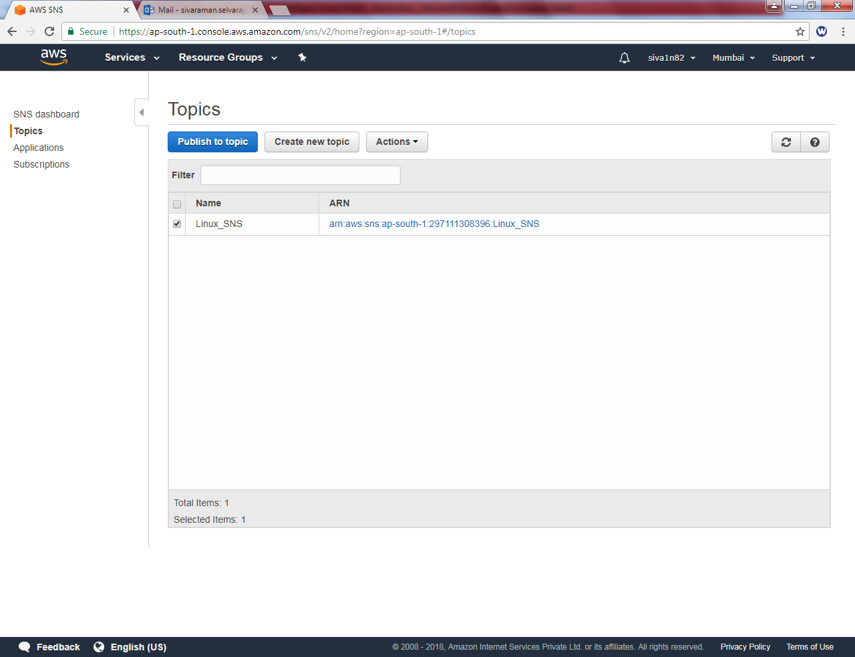

Actions Delete topics

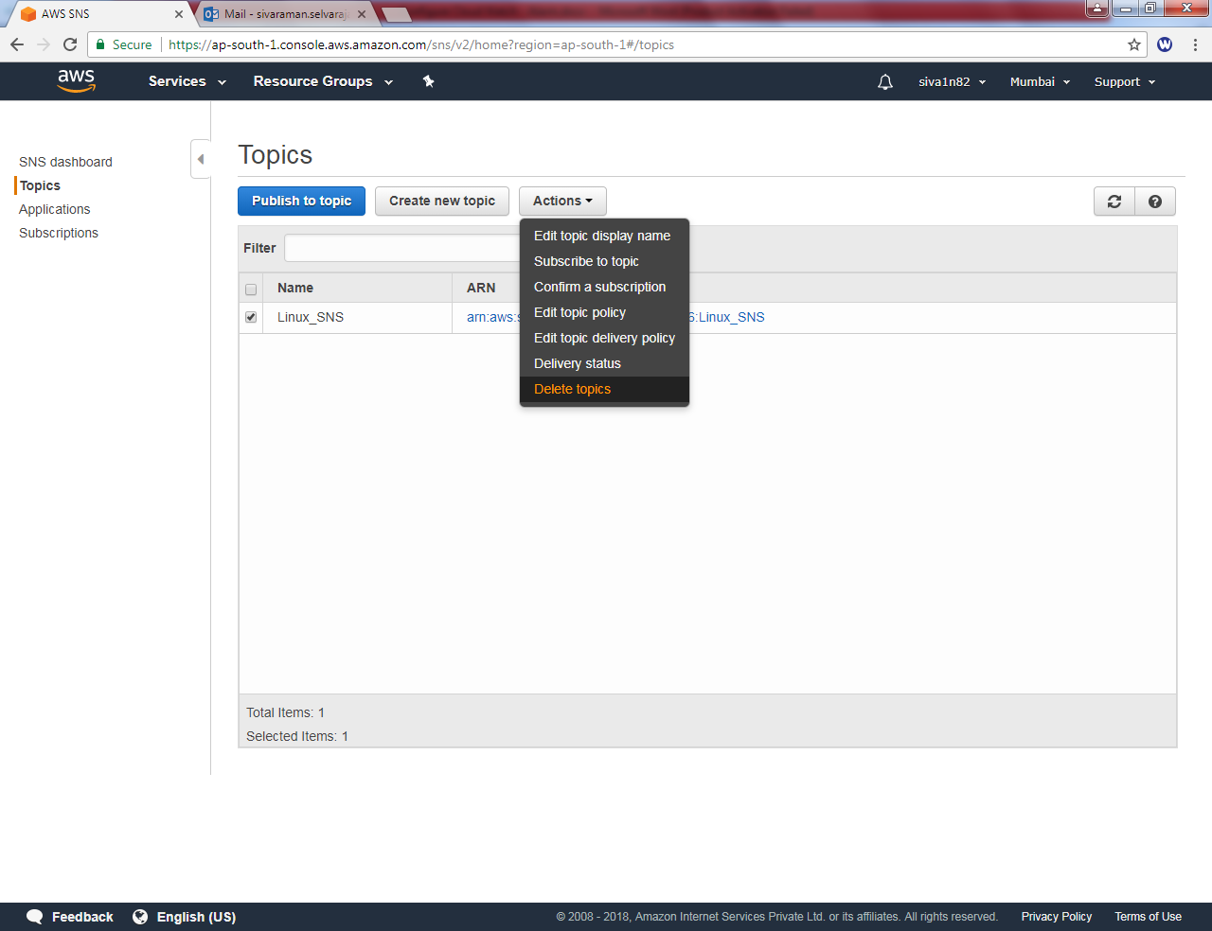

Click “Delete”.

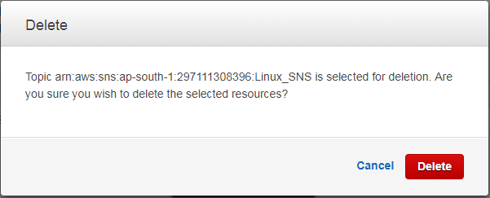

Click “Subscriptions”
Click “Checkbox”
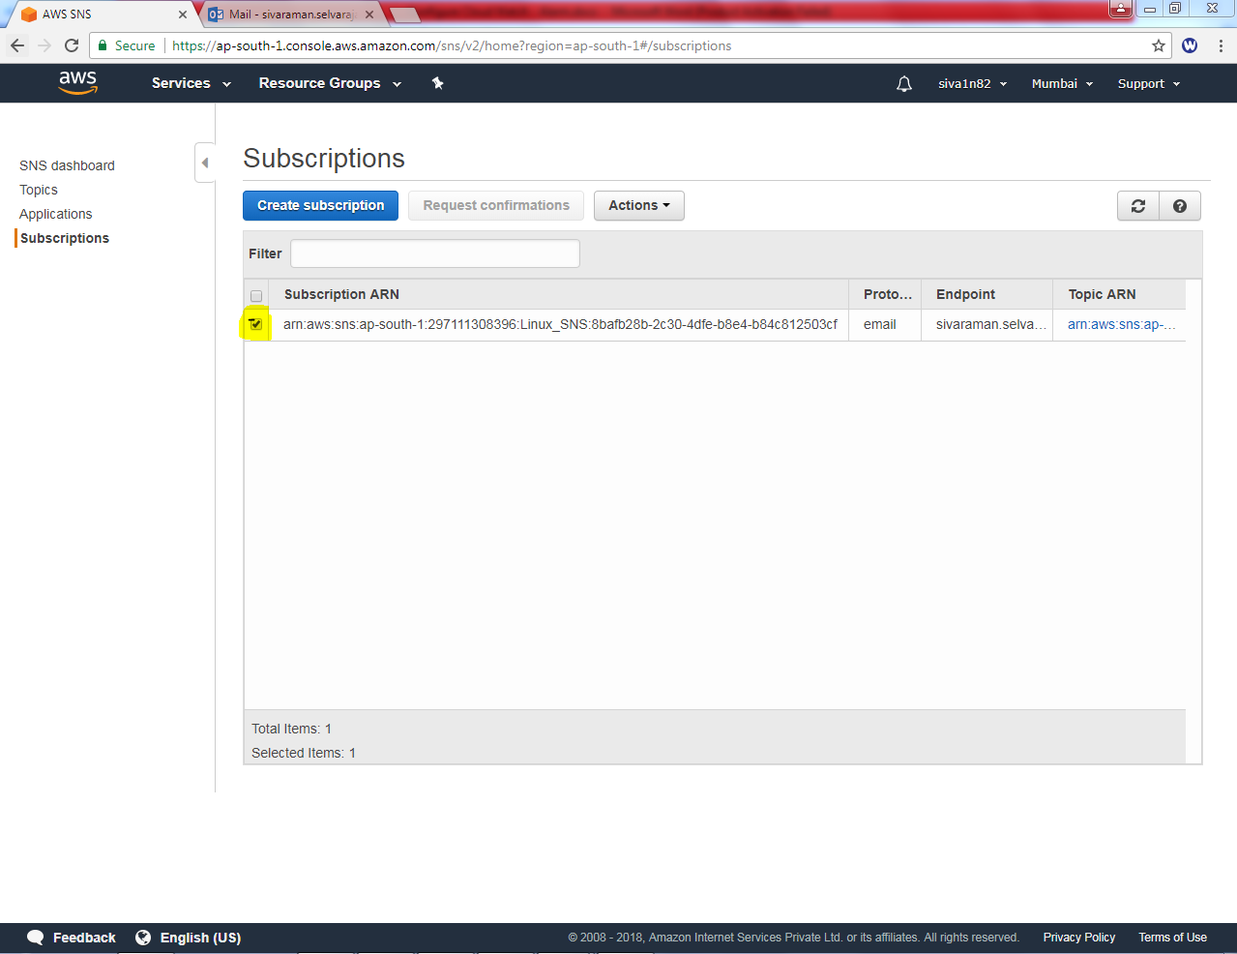

Click Actions “Delete subscription”

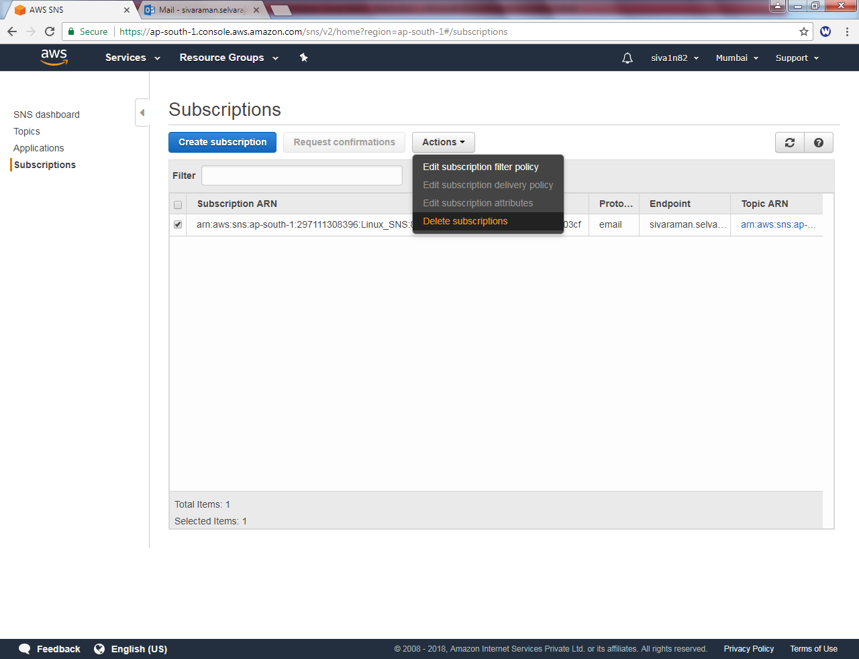

Click “Delete”.
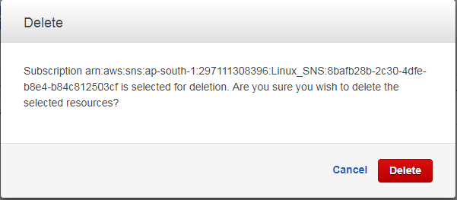

Click “Cloudwatch”
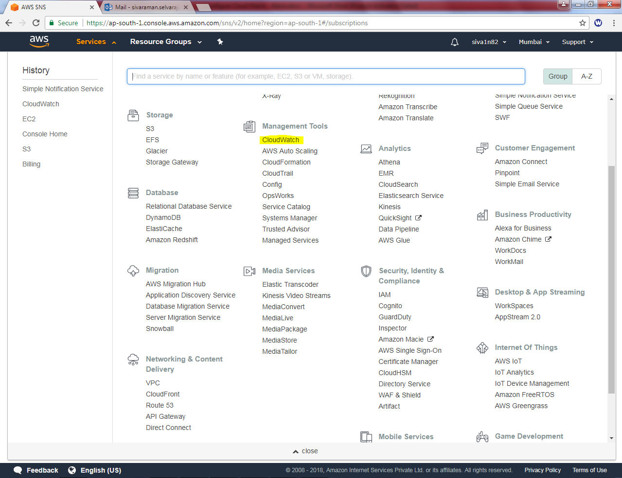

Click “INSUFFICIENT” then click checkbox
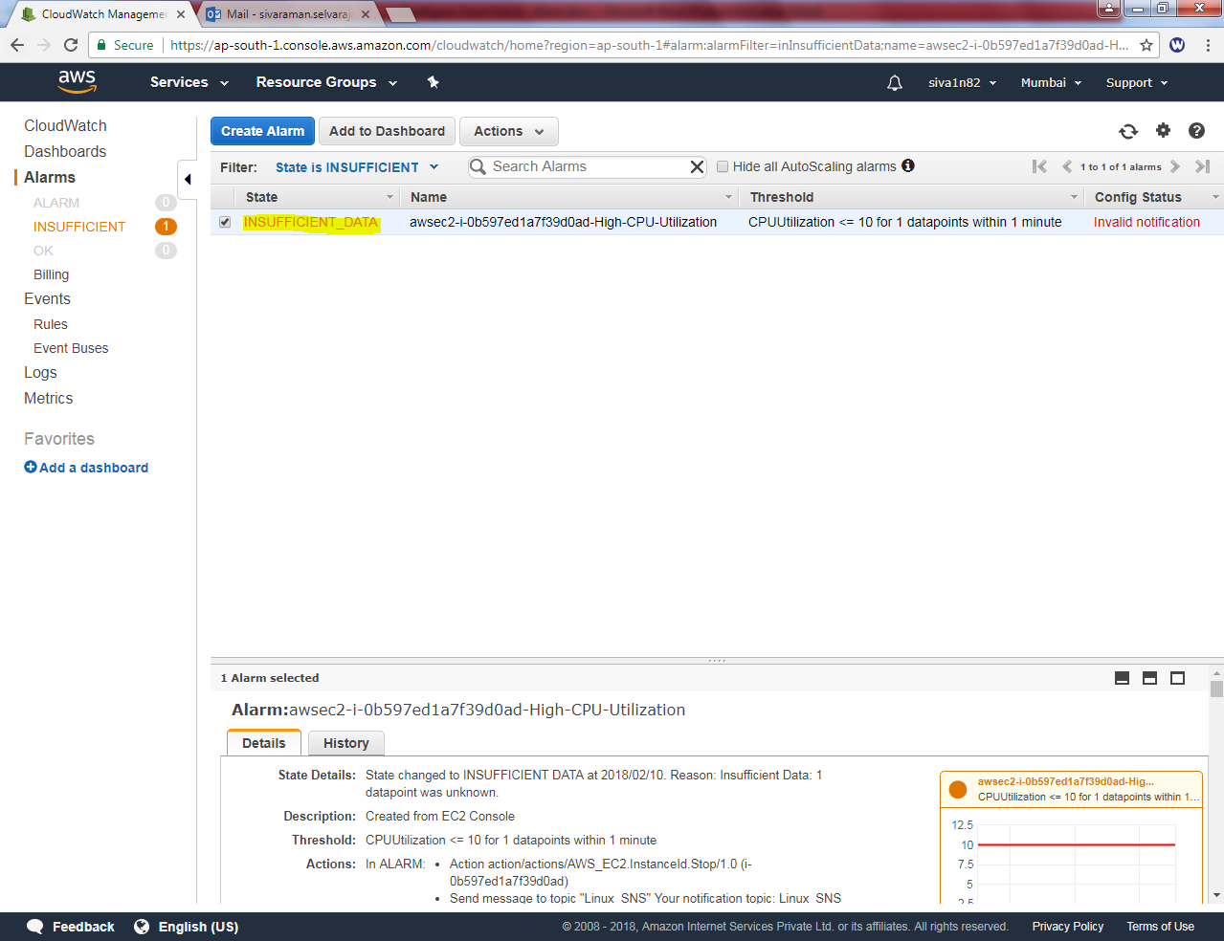

Click “Actions” Delete
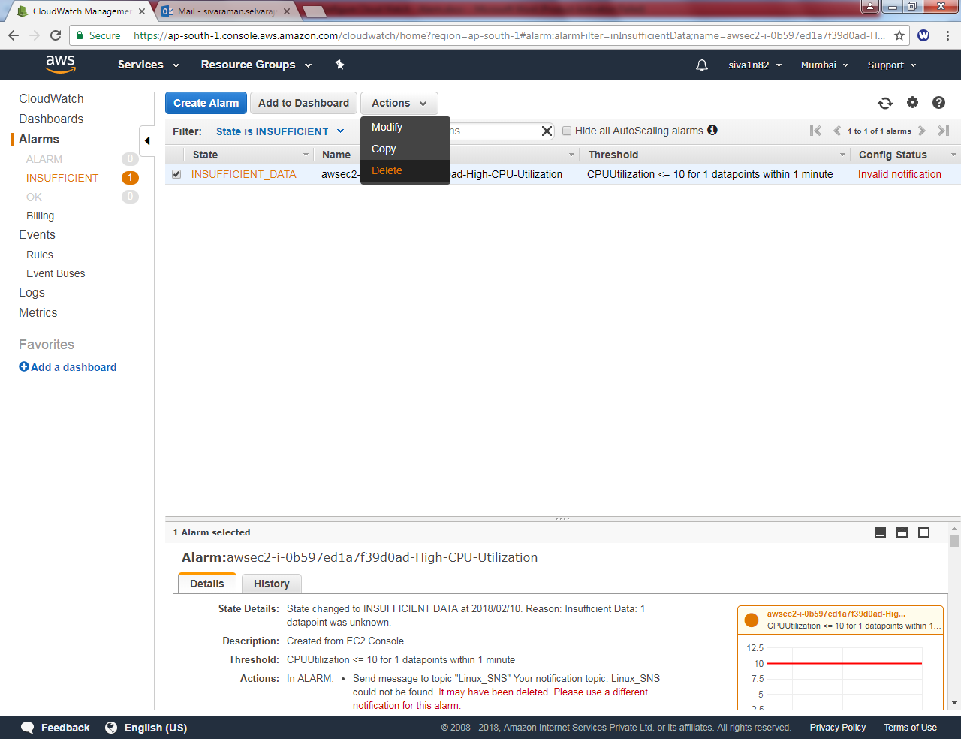

Click ”Yes, Delete”
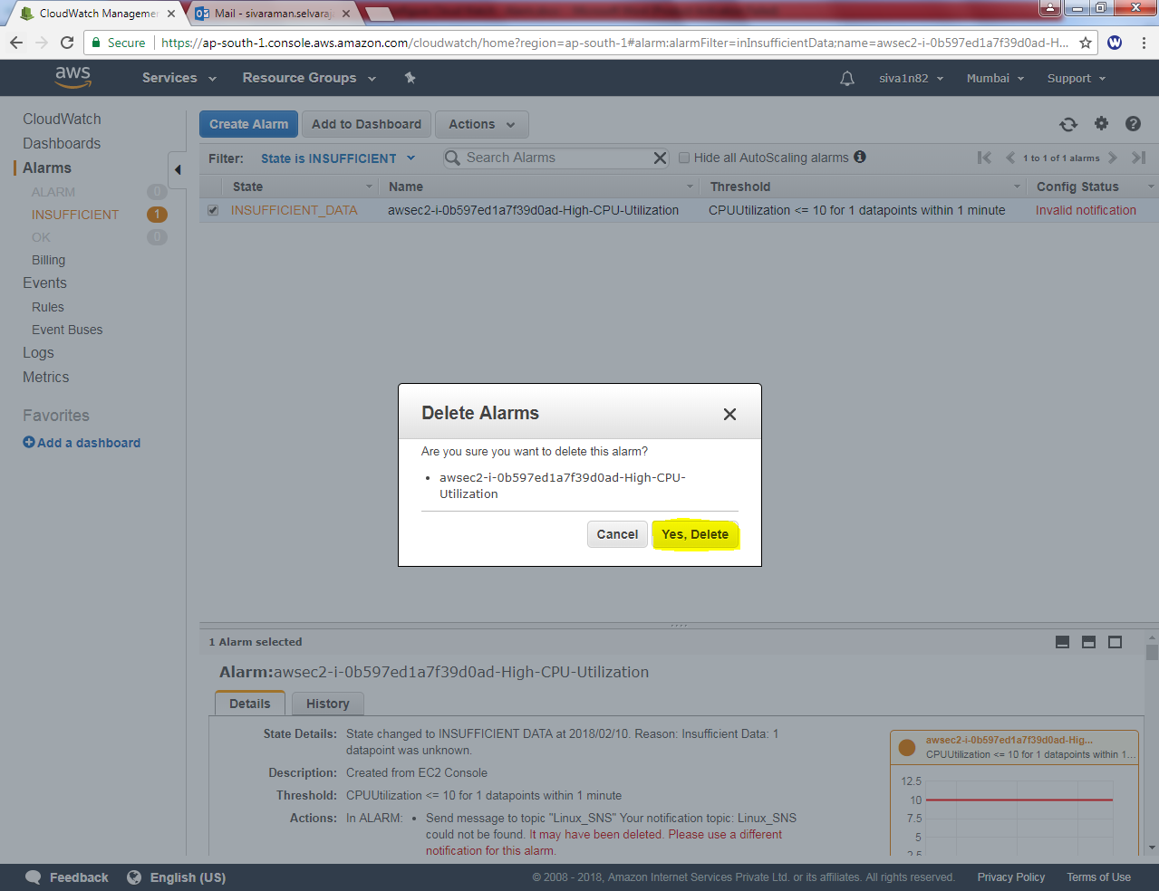

You have no cloudwatch.
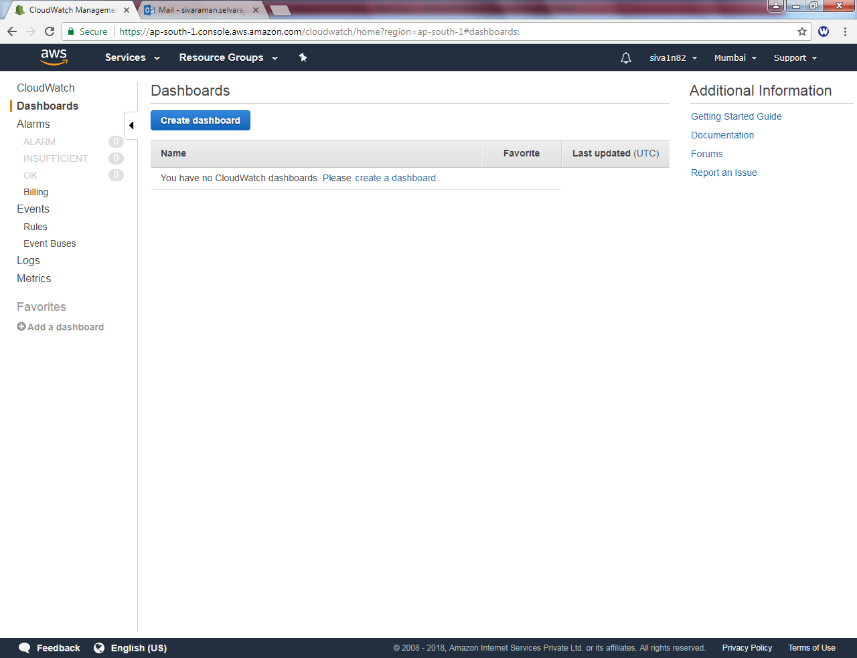

Click EC2 to terminate the instance.

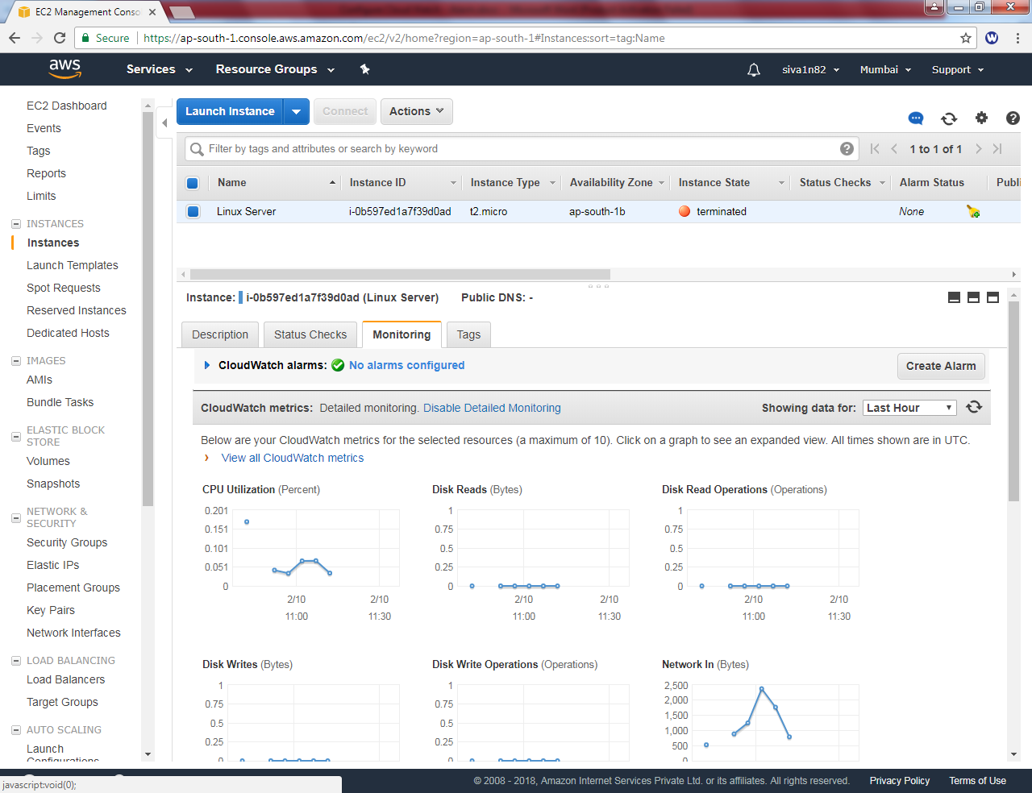

Click “Disable detailed monitoring”
